Source Code of Email Validation**:**

package Practice_Projects;

import java.util.Scanner;

public class EmailValidation {

public static void main(String[] args) {

// Initialize the array of email IDs

String[] emailIDs = {"emp1@Company.com", "emp2@Company.com", "emp3@Company.com", "emp4@Company.com"};

// Prompt the user to enter an email ID to search for

Scanner scanner = new Scanner(System.***in***);

System.***out***.print("Enter an email ID to search for: \n");

String searchEmailID = scanner.nextLine();

// Search for the email ID in the array

boolean found = false;

for (String emailID : emailIDs) {

if (emailID.equals(searchEmailID)) {

found = true;

break;

}

}

// Print the result

if (found) {

System.***out***.println(searchEmailID + " was found in the array.");

} else {

System.***out***.println(searchEmailID + " was not found in the array.");

}

}

}

Screenshot output of Email Validation:

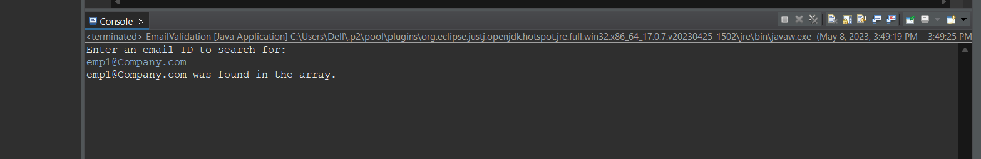

Write up for email validation:

Step1 - START

Step 2 - Initialize an array of email IDs (already registered in a

company).

Step 3 - Prompt the user to enter an email ID to search for

Step 4 - Read the user input using Scanner class

Step 5 - Set a boolean variable found to false

Step 6 - Loop through the array of email IDs

Step 7 - Compare each email ID to the search email ID using the

equals method.

Step 8 - If a match is found, set the found variable to true and

break out of the loop

Step 9 - Print the result based on the value of the found variable.

Step 10 - Stop